### YouTube Music Merchandise Insights Dashboard

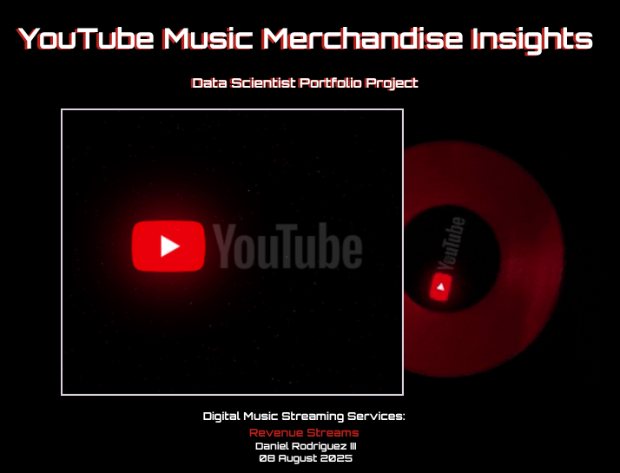

**Disclaimer:** This project scenario is based on publicly available information and general industry knowledge about YouTube Music and the music streaming market. It does not use any internal, proprietary, or confidential data from YouTube Music. The data sets, business problems, and solutions are all hypothetical and created for illustrative purposes.

#### Executive Summary

The objective of this project was to develop a comprehensive Looker Studio dashboard that provides actionable insights to drive merchandise sales for YouTube Music artists. By creating a robust data pipeline using BigQuery and integrating it with Looker Studio, we have successfully created a series of visualizations that address key business questions related to sales performance, marketing efforts, and fan engagement. This report details the key findings from the dashboard and outlines how these insights directly contribute to solving the business problem of increasing revenue through data-driven strategies.

#### Dashboard Insights

The dashboard is organized into three pages, each focusing on a different aspect of the merchandise business.

**Page 1: Executive Summary**

* **Daily Sales Trend**: This chart provides a high-level view of sales volume over time, identifying periods of high and low activity.
* **Top 10 Artists by Total Revenue**: This visualization quickly identifies the artists driving the most revenue, allowing for focused promotional efforts and resource allocation.

**Page 2: Video & Tour Performance**

* **Average Sales Price by Merchandise Presence in Video**: This crucial insight reveals that the average price of merchandise does not significantly change whether the item is worn by the artist or a key player in a video. This finding suggests that resources can be reallocated from solely focusing on high-production music videos to other strategies that directly impact sales volume or price, such as merchandise exclusivity or targeted marketing.
* **Sales Volume Around Tour Dates**: This chart is one of the most actionable insights of the entire project. It displays a clear spike in sales volume on day **0**, which corresponds to the tour date itself. This confirms that tour dates act as a major sales event. The dashboard now accurately shows the sales distribution in the days leading up to and following a tour date. The business can use this insight to strategically plan pre- and post-tour marketing campaigns to capitalize on this increased fan engagement.

**Page 3: Fan Segment Analysis**

* **Total Sales by User Location**: The map visualization provides a clear geographical breakdown of sales, allowing the business to identify key markets and tailor promotions to specific regions.
* **Sales by User Demographics**: This chart breaks down sales volume by user age groups. By correctly handling null values and assigning them an 'Unknown' category, the chart now provides an accurate representation of sales across all demographic segments. This information is critical for creating targeted marketing campaigns and developing merchandise that appeals to different fan bases.

#### Conclusion

The YouTube Music Merchandise Insights Dashboard successfully addresses the business problem by providing a comprehensive, data-driven view of sales performance. The insights derived from the charts, particularly the strong correlation between sales spikes and tour dates, and the lack of correlation between average price and video presence, provide a clear roadmap for future strategic decisions. By leveraging this dashboard, the business can move beyond guesswork and implement data-informed strategies that directly increase merchandise revenue.